NAME

ASSIGNMENT NO 4

QUESTION NO 1:

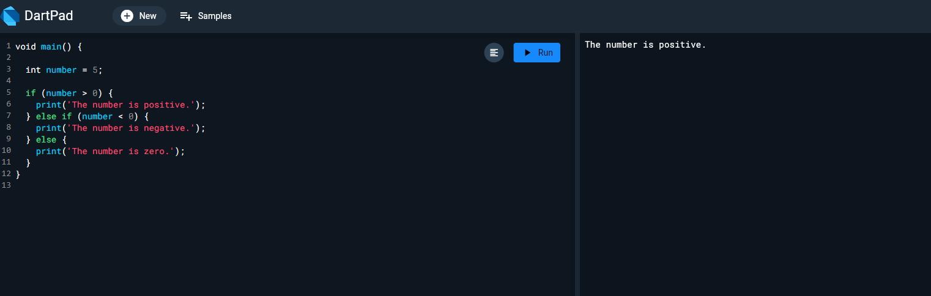

QUESTION NO 2:

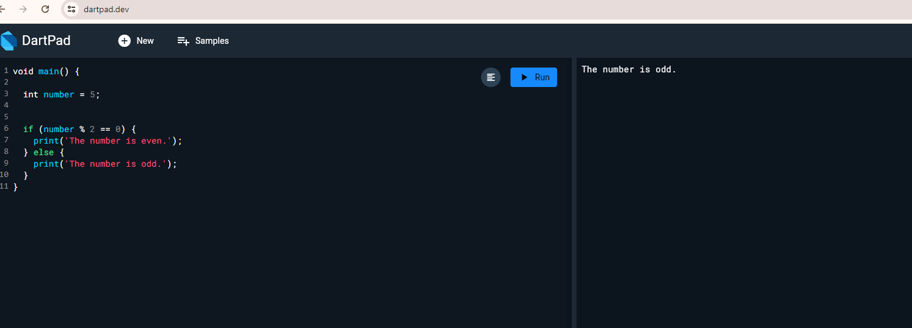

QUESTION NO 3:

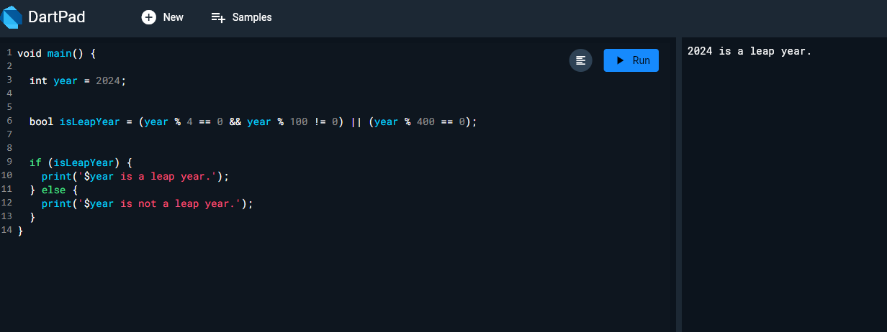

QUESTION NO 4:

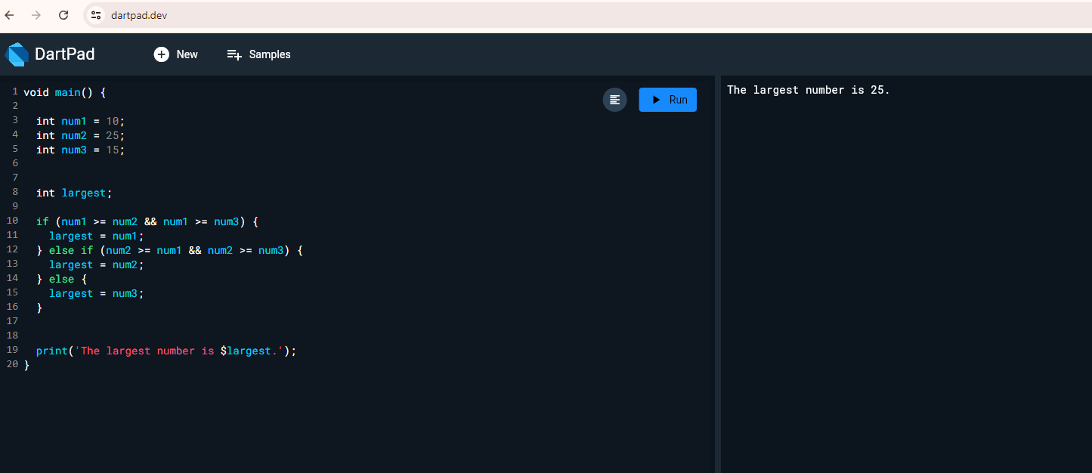

QUESTION NO 5:

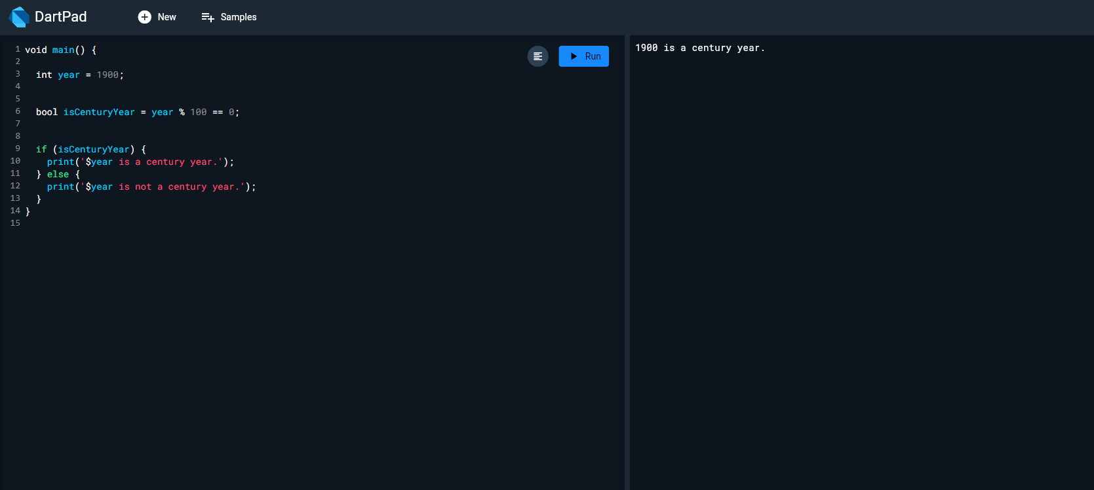

QUESTION NO 6:

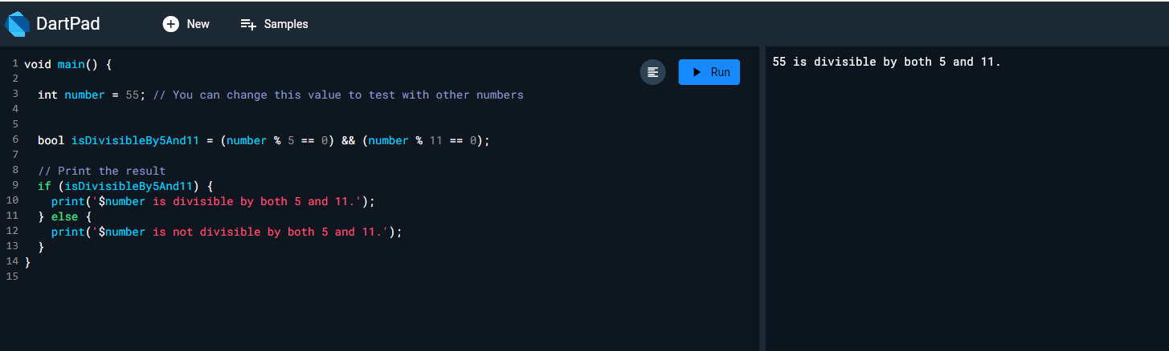

QUESTION NO 7:

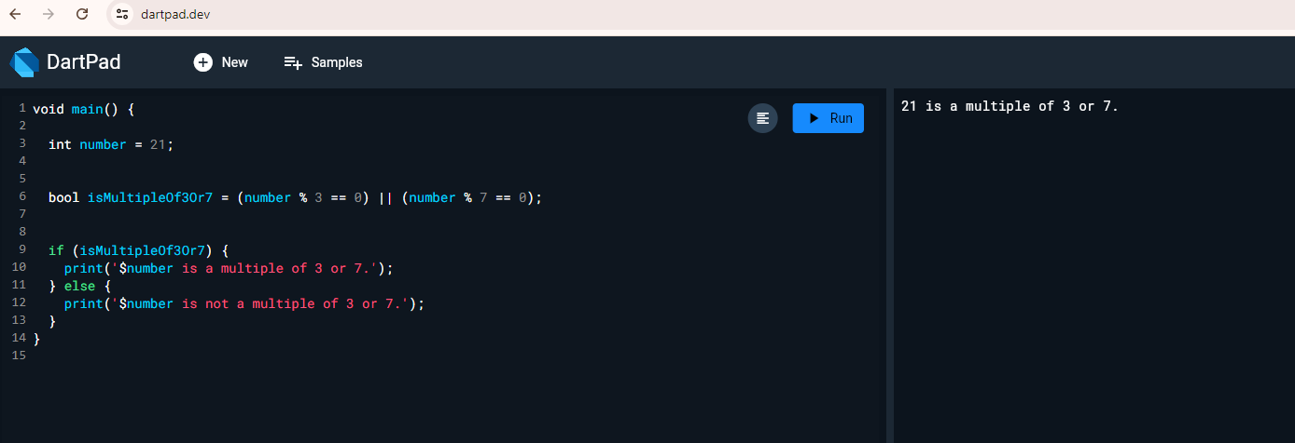

GitHub Profile Link:

